**WHAT IS AN SQL?**

SQL stands for Structured Query Language and it is a standard language for storing, manipulating and retrieving data in databases.

**USES**

* SQL can execute queries against a database
* SQL can retrieve data from a database
* SQL can insert records in a database
* SQL can update records in a database
* SQL can delete records from a database
* SQL can create new databases
* SQL can create new tables in a database
* SQL can create stored procedures in a database
* SQL can create views in a database
* SQL can set permissions on tables, procedures, and views

**WHAT IS A DBMS?**

DBMS stands for Database Management Systems. Database Management Systems (DBMS) are software systems used to store, retrieve, and run queries on data. A DBMS serves as an interface between an end-user and a database, allowing users to create, read, update, and delete data in the database. DBMS manage the data, the database engine, and the database schema, allowing for data to be manipulated or extracted by users and other programs. This helps provide data security, data integrity, concurrency, and uniform data administration procedures. DBMS optimizes the organization of data by following a database schema design technique called normalization, which splits a large table into smaller tables when any of its attributes have redundancy in values. DBMS offer many benefits over traditional file systems, including flexibility and a more complex backup system.

**SHOW HOW TO CREATE A DATABASE AND A TABLE IN SQL**

The CREATE DATABASE statement is used to create a new SQL database. The following SQL statement creates a database called "REGISTER":

### Example

CREATE DATABASE REGISTER;

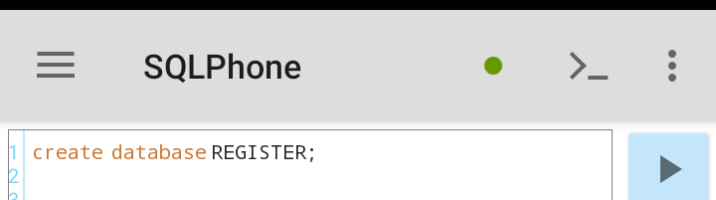

The CREATE TABLE statement is used to create a new table in a database. The following SQL statement creates a table in the selected database.

**Example**

CREATE TABLE table_name (

column1 datatype, column2 datatype, column3 datatype, ....  
);

Note that the column parameters specify the names of the columns of the table.

The datatype parameter specifies the type of data the column can hold (e.g. varchar, integer, date, etc.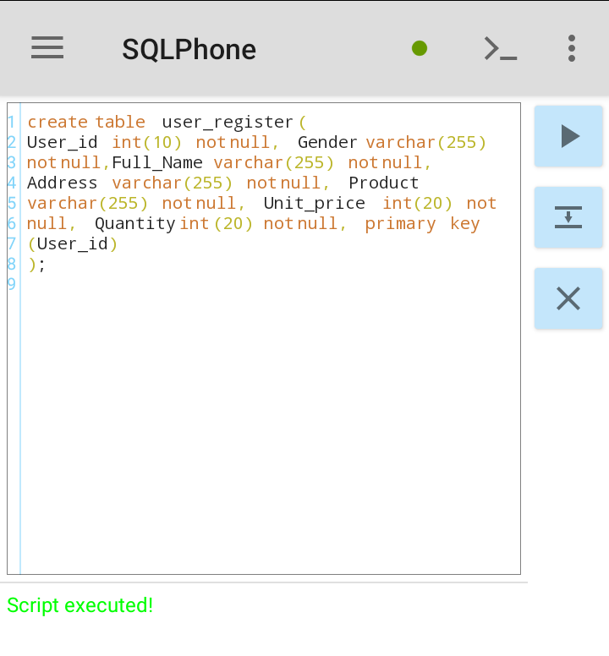**CREATE A DEMO TABLE CALLED users_register, ENTER 10 RECORDS USING user_id AS PRIMARY KEY**

The queries go as thus:

**CREATE TABLE** user_register (

User_id int(10) Not Null, Gender Varchar(20) Not Null, Full_Name Varchar(255) Not Null, Address Varchar(255) Not Null, Product Varchar(255) Not Null, Unit_Price int(20) Not Null, Quantity int(20) Not Null, primary key(user_id)

)**;**

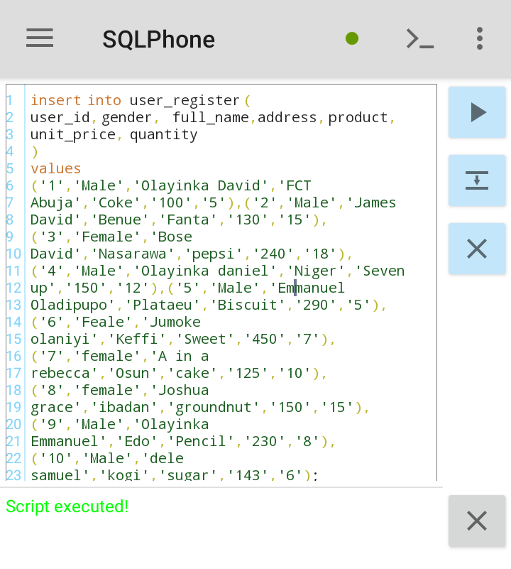

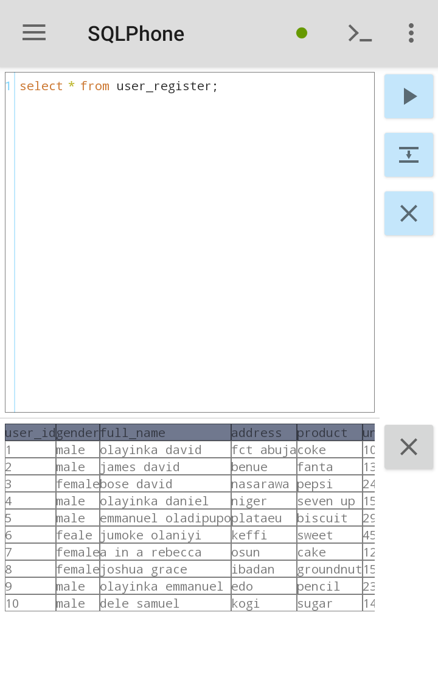

**EXPLAIN THE FOLLOWING SQL AGGREGATE FUNCTIONS WITH PRACTICAL EXAMPLES AT LEAST 2**

The SQL SUM() Function: Itreturns the **sum** of all values or the **sum** of only values specified through conditional expressions.

The SQL AVG() Function: It returns the average value of a numeric column.

The SQL MIN() Function: It returns the smallest value of the selected column.

The SQL MAX() Function: It returns the largest value of the selected column.

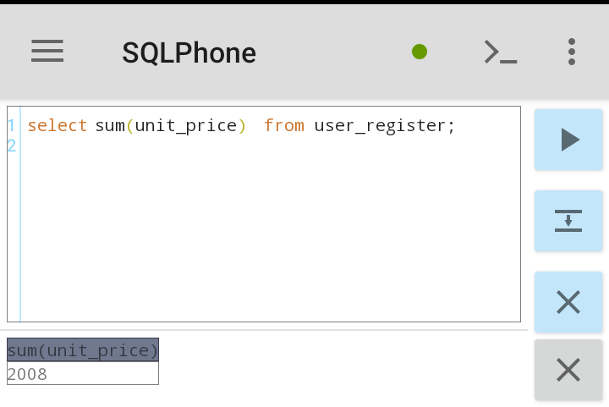

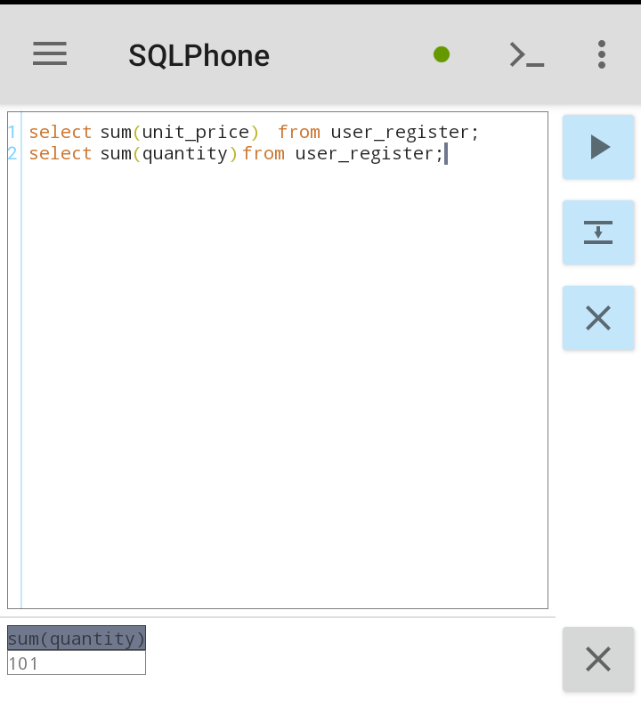

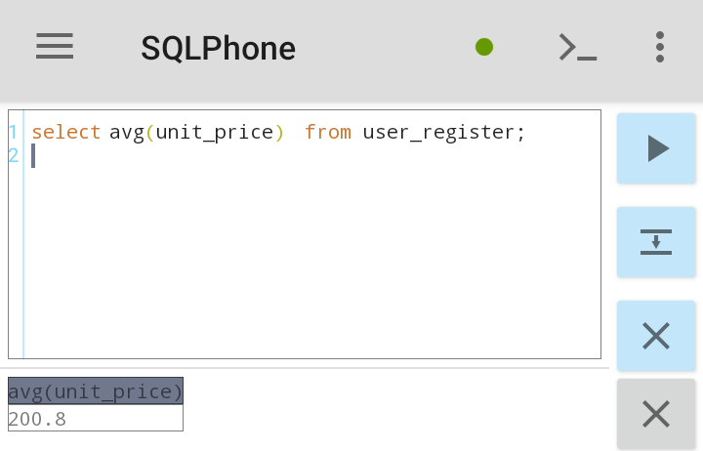

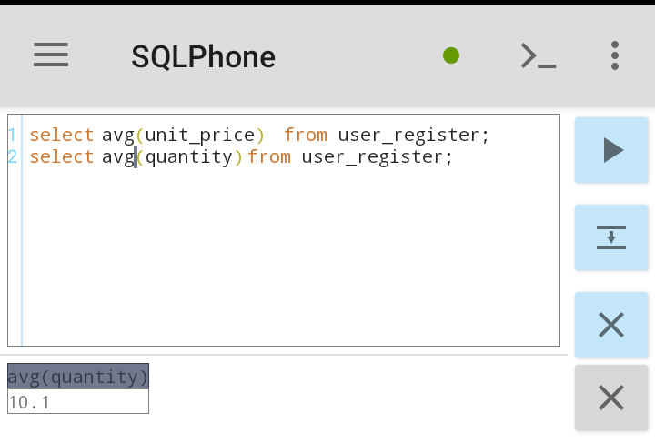

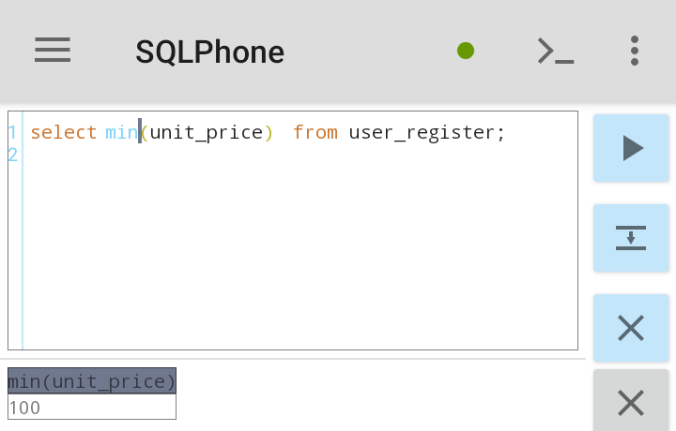

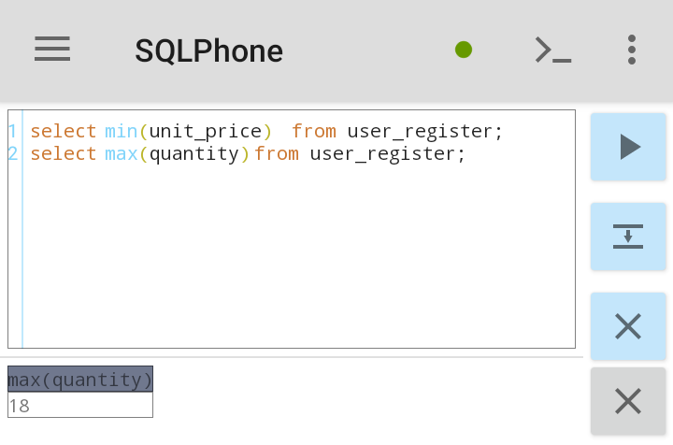

**WRITE AN SQL QUERY TO SHOW TODAYS DATE**

The CURRENT_TIMESTAMP function returns the current date and time, in a 'YYYY-MM-DD hh:mm:ss.mmm' format.

### Example

SELECT CURRENT_TIMESTAMP;

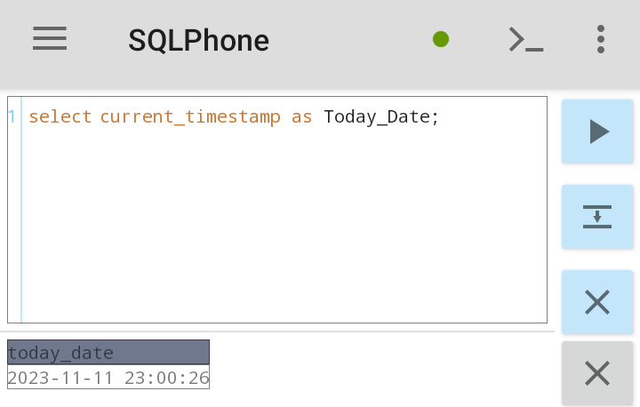

**YOU ARE AN EMPLOYER IN AN ORGANIZATION, WRITE AN SQL QUERY TO TRACK SALES ORDER BY DATE**

**Example**

SELECT sales_id, sales_date FROM sales_record ORDER BY sales_date;

**EXPLAIN THE FOLLOWING DATE FUNCTIONS, NOW(), DATE_ADD(), DATE_SUB(), DATEDIFF()**

NOW(): This function returns the current date and time. Which is returned as ‘YYYY-MM-DD-HH-MM-SS.

DATE_ADD(): This function adds a whole number increment to a specific date value and return the date.

DATE_SUB(): This function subtract a time/date interval from a date.

DATEDIFF(): This function compares two dates and return the difference.

**EXPLAIN BETWEEN AND ITS USE-CASE IN SQL**

The BETWEEN command is used to select values within a given range. The values can be numbers, text, or dates. The begin and end values are included.

**Example**

The following SQL statement selects all sales with a price BETWEEN 2000 and 3000:

SELECT * FROM Products WHERE Price BETWEEN 2000 AND 3000;